{{email}}

**Roof**

We would like to install solar panels on a roof mount to help offset electricity costs. The panels will be black anodized corrosion resistant with a black aluminum frame. They will be made with low glare anti-reflective coated (ARC) tempered glass. Please refer to the attached specification sheets for more information.

{{phone}}

{{address}}

{{address}}

{{name}}

{{hoa_name}}

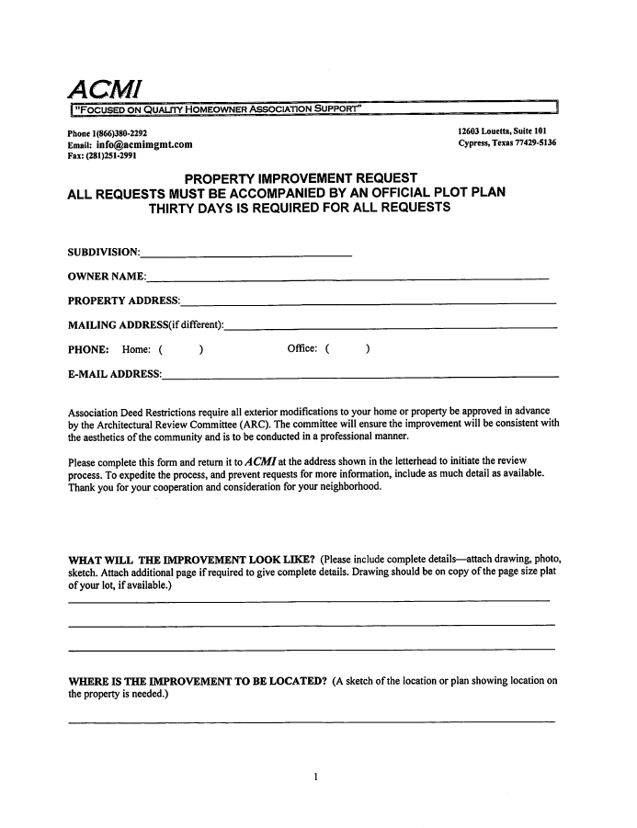

{{date}}

2 construction days

Pending Approval

